Chapter 13:

The Impending Crisis

The AP instructional strategies discussed below for Chapter 13 of American

History: A Survey focus especially, but not exclusively, on the following themes developed by the AP U.S. History Development Committee: American Diversity, American Identity, Demographic Changes, Slavery and Its Legacies in North America, and War and Diplomacy. This chapter, as well as the primary documents selected below, follow the content guidelines suggested for the ninth and tenth topics in the AP Topic Outline − Territorial Expansion and Manifest Destiny and The Crisis of the Union.

Top-Ten Analytical Journal.

Defining the chapter terms in their journals will help students better understand:

- Manifest Destiny, and its influence on the nation in the 1840s.
- The origin of the Republic of Texas, and the controversy concerning its annexation by the United States.
- The reasons why the United States declared war on Mexico, and how the Mexican War was fought to a successful conclusion.
- The methods used to enact the Compromise of 1850, and its reception by the American people.
- The role of the major political parties in the widening sectional split.
- The part played by Stephen A. Douglas in the enactment of the Kansas-Nebraska Act, and the effect of this act on his career and on the attitudes of the people in all sections.
- The impact of the Dred Scott decision on sectional attitudes and on the prestige of the Supreme Court.
- The reasons for Abraham Lincoln's victory in 1860, and the effect of his election on the sectional crisis.

Each of the terms below contributes to a comprehensive understanding of how the idea of Manifest Destiny influenced America, how the question of expanding slavery deepened divisions between the North and the South, and how the issue of slavery reshaped the American political-party system. As your students define these terms, encourage them to demonstrate why each person, event, concept, or issue is important to a thorough understanding of this chapter.

Manifest Destiny
Stephen Austin
General Santa Anna
The Alamo and Battle of San Jacinto
Texas Annexation
Oregon Trail
James K. Polk
The Mexican War
Treaty of Guadalupe Hidalgo
Wilmot Proviso
Popular sovereignty
Election of 1848
California Gold Rush
Henry Clay
John C. Calhoun
Daniel Webster
Stephen Douglas
Free-Soil Party
Fugitive Slave Act
Franklin Pierce
Transcontinental Railroad
Gadsden Purchase
Kansas-Nebraska Act
Republican Party
John Brown
Slave Power Conspiracy
Election of 1856
James Buchanan
Know Nothing Party
Dred Scott Decision
Lincoln-Douglas Debates
Election of 1860

Getting students started on their journals. Remind students that they must analyze and synthesize their understanding of these terms in two ways:

- by creating “Top-Ten” lists of their own within their journals at the end of each chapter; and
- by justifying in their journal why their terms are essential to an understanding of “The Impending Crisis.”

Journal entry example. Following is an example of how students might describe “Texas Annexation” and its importance to an overall understanding of “The Impending Crisis.”

Texas Annexation. After the creation of the Republic of Texas, many Texans and Americans favored annexation to the U.S. The first effort to annex, conducted in 1836, failed, largely because northerners opposed acquiring new slave territory and increasing southern votes in Congress and the Electoral College. In 1845, when Texas finally became a state, the Mexican government broke diplomatic relations with the U.S. and relations between the two countries worsened. Annexation and a later boundary dispute eventually led to war between Mexico and the U.S.

Free-Response Questions.

- While most Americans believed Manifest Destiny was a positive and progressive movement, it should be more factually described as aggressive imperialism that was pursued at the expense of many other people. Assess the validity of this statement. (Adapted from the 1990 AP U.S. History free-response question.)

Some things to look for in the student response.

- Possible thesis statement: Depending on one’s perspective, Manifest Destiny can be seen as both a progressive movement of American nationalism or a regressive, racist movement of American imperialism.

- Progressive movement. Westward expansion was an altruistic effort to expand the many benefits of American freedom and democracy throughout North America. Because the Mexican government invited American colonists into Mexico and later into New Mexico, thousands of Americans took advantage of Mexico’s welcome. Texas, and later New Mexico, quickly became more American than Mexican. White immigration into the western territories would eliminate Indian resistance. Each of these factors demonstrates that Manifest Destiny was essential to the spread of democracy, capitalism, and Americanism to the entire North American continent.

- Regressive movement. Westward expansion was designed to force a superior political, social, and economic system upon racially inferior people. When the Mexican government tried to bar American immigration, Americans continued to enter and settle on Mexican land illegally. President Polk staged the border incident and deliberately maneuvered the U.S. into the war so he could gain more of Mexico’s territory. The South’s uncompromising support of extending slavery into the territories was an attempt to spread racial slavery across North America and to assert southern control over the political, social, and economic system. Each of these factors demonstrates that the policies of Manifest Destiny were designed to increase the borders of the U.S. at the expense of its neighbors, as well as to subdue “inferior” people such as the Mexicans and Indians who stood in the way of the expansion of a “superior people.”

- Possible conclusion: Depending on the position of a mid-19th century American, the policies of Manifest Destiny were either a positive, progressive movement or a negative, regressive movement. In retrospect, many scholars increasingly have argued the on behalf of the latter perspective.

2. Discuss the causes of the Mexican War. What were the domestic consequences of the War?

Some things to look for in the student response.

- Possible thesis statement: Even though opposition existed throughout much of the Mexican War, when the war was over, most Americans were pleased that they had gained a vast new territory.

- Causes. American immigration into Mexico, first with the government’s approval and later in violation of the law. Disproportionate number of Americans living on Mexican land, who at first preferred to be independent and later wanted to be annexed to the U.S. government. Annexation debate between pro- and anti-slavery advocates in the U.S. Congress. President Polk’s desire to spread the borders of the U.S. across North America at the expense of the Mexicans and Indian nations. The boundary dispute over the Republic of Texas. Polk’s purposeful maneuvering of circumstances leading to war.

- Domestic consequences. Furthered dissention about the extension of slavery into the territories and new states. Some Americans opposed war with Mexico because they did not want the annexation of a huge new territory where slavery could be extended. Southerners, however, argued that all Americans had equal rights in the territories, including the right to move their property (slaves). Opposition to the casualties and expense of the war arose during the war, and afterwards, some argued that Polk had settled for less both in Oregon and in Mexico.

- Possible conclusion: When the war was over, a new set of troubling and divisive issues arose over how to settle the territories. The most pressing question remained: would they be open or closed to slavery?

3. Analyze the factors that caused the deep divisions between the North and South during the 1850s.

Some things to look for in the student response.

- Possible thesis statement: By 1850, the South and North failed to agree on many political, social, and economic issues. Inextricably entwined with every disagreement was the issue over the extension of slavery into the new territories. In the decade before the war, every attempt at compromise eventually ended in a stalemate largely due to several major events.

- Transcontinental Railroad. While both northerners and southerners agreed that better transportation was needed to facilitate westward expansion, differences emerged over the route of a transcontinental railroad. Northerners preferred an eastern terminus through Chicago, while southerners argued for St. Louis, Memphis, or New Orleans.

- Kansas-Nebraska Act. In his plan to get the South to agree to the Chicago terminus, Stephen Douglas proposed a compromise bill to repeal the Missouri Compromise outlawing slavery in the northern territory and to organize two new territories − Nebraska, where the status of slavery would be determined by popular sovereignty, and Kansas, which would be open to slavery. The consequences of this Act were enormous: it divided and destroyed the Whig Party, divided the northern Democrats, and encouraged the creation of a new, clearly sectional party, the Republicans.

- “Bleeding Kansas.” The promise of popular sovereignty brought anti-slavery and pro-slavery supporters into Kansas, each with their own agenda. One of the fiercest was that of John Brown, a religious zealot who believed it was God’s will that he destroy slavery. After he and his sons murdered five pro-slavery settlers, he fled the area. Nonetheless, “Bleeding Kansas” became symbolic of the inability of political compromise to bring the nation together.

- Free Soil and Free Labor. In the North, many believed that slavery must be abolished because it threatened northerners’ chances for jobs in the territories. They viewed the South as engaged in a “slave power conspiracy” designed to destroy northern capitalism and replace it with their closed, aristocratic system. The South argued that slave labor was a “good − a positive good” for the slaves who enjoyed better conditions than did free blacks in the North, and that slavery was the basis for the southern way of life, which was superior to any other way o f life in the U.S., perhaps in the entire world.

- Dred Scott Decision. This 1856 Supreme Court decision found that Scott, a slave, could not bring a suit in federal courts because he was not a citizen; that blacks were property, and as such, had no claim to citizenship and virtually no rights under the Constitution; and that Congress had no right to pass a law depriving persons of their slave property in the territories. This statement that the federal government was powerless to act on the issue of slavery further split the North and the South.

- John Brown’s raid on Harper’s Ferry. While Brown’s effort to begin a slave rebellion failed and he was tried, convicted, and hung for treason, the raid incorrectly convinced many white southerners that Brown was supported by the Republicans and they could no longer live safely in the Union.

- The Election of Lincoln in 1860. The Republican nomination of Lincoln and the splintering of the Democrats − between southerners who demanded a strong endorsement of slavery and westerners who supported popular sovereignty − led to a contentious and historic election. Lincoln’s election was the final straw for many white southerners who began the process of secession within weeks after the election.

- Possible conclusion: While political compromise opened the decade in 1850, compromise was dead ten years later. Each of the above events drew a clearer line between the North and the South and where they stood on the issue of slavery in the western territories.

Historians, Historical Detection, and DBQs

The following DBQ and its supportive primary documents will help students gain a better understanding of the “impending crisis” − the complex issues that characterized America prior to the Civil War. Remind your students that when scoring the AP exams, the readers will expect to see a coherent essay that includes two required components: key pieces of evidence from all or most of the documents and a well-organized narrative drawing on knowledge from textbook readings and classroom discussion.

DBQ: Using the documents below, analyze how the issues contributing to the Mexican War, as well as the War’s consequences, contributed to the divisions in America.

Documents:

- “Corpus Christi Landing,” Lithograph, October 1845. ("Birds-eye view, of the camp of the 'Army of Occupation,' near Corpus Christi, Texas as in October 1845." Fenderich, no. 241. Library of Congress Prints and Photographs Division. ID: LC-USZ62-58542.)

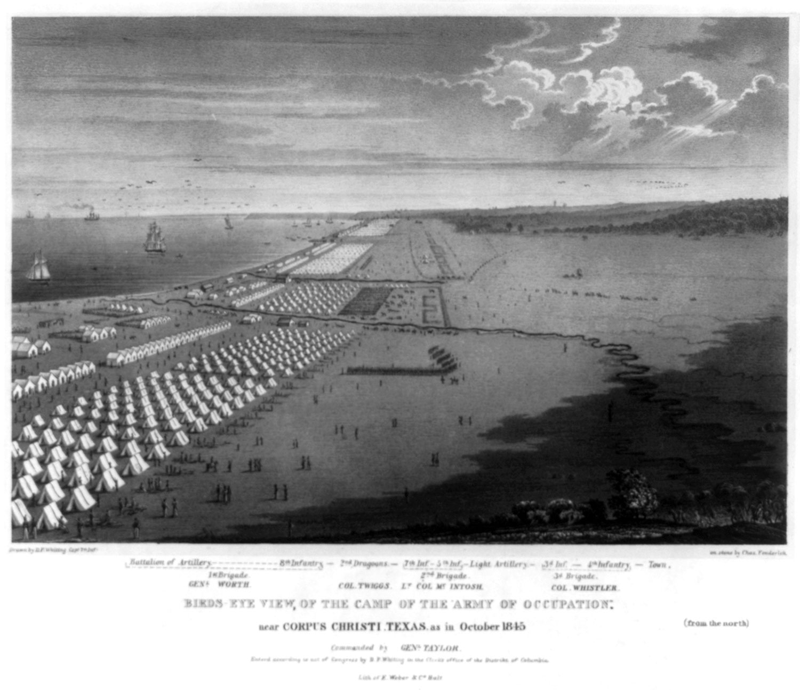

2. Wilmot Proviso as explained in theCongressional Globe, 29th Cong., 1846, 1st session., 1213-1217.

“…Mr. Wilmot regretted that the President had not disclosed his views. He disliked to act in the dark on this or any subject. If this had been done, and it had been inexpedient to have received and deliberated upon it publicly, they might have gone into secret session. He would vote for this appropriation in case the amendment he intended to offer was adopted. He disagreed with some of his friends that this was an unnecessary war; he believed it a necessary and proper war. He believed it not to be a war of conquest; if so he was opposed to it now and hereafter. If this country was now to be forced into such a war, he pronounced it against the spirit of the age, against the holy precepts of our religion; he was opposed to it in every form and shape. But he trusted it was not to be a war of conquest. He trusted that the President was sincerely ready to negotiate for an honorable peace.

But the President asked for two millions of dollars for concessions which Mexico was to make. We claim the Rio Grande as our boundary--that was the main cause of the war. Are we now to purchase what we claim as a matter of right? Certainly she was not to be paid for the debt she owes our citizens . . .

But whatever territory might be acquired, he declared himself opposed, now and forever, to the extension of this "peculiar institution" that belongs to the South. He referred to the annexation of Texas, and to his affirmative vote on the proposition connected with it at this session; he was for taking it as it was: slavery had already been established there. But if free territory comes in, God forbid that he should be the means of planting this institution upon it.

He concluded by offering the amendment . . . providing against the establishment of slavery, or involuntary servitude, in any territory which may be acquired . . .”

3. “Volunteers in New Hampshire,” War recruitment poster for the State of New Hampshire, February 1847. ("Volunteers! Men of the granite state! Men of Old Rockingham!!" Portsmouth, 1847. Printed Ephemera Collection; Portfolio 93, Folder 17b. Library of Congress American Memory Project. ID: rbpe 0930170b.)

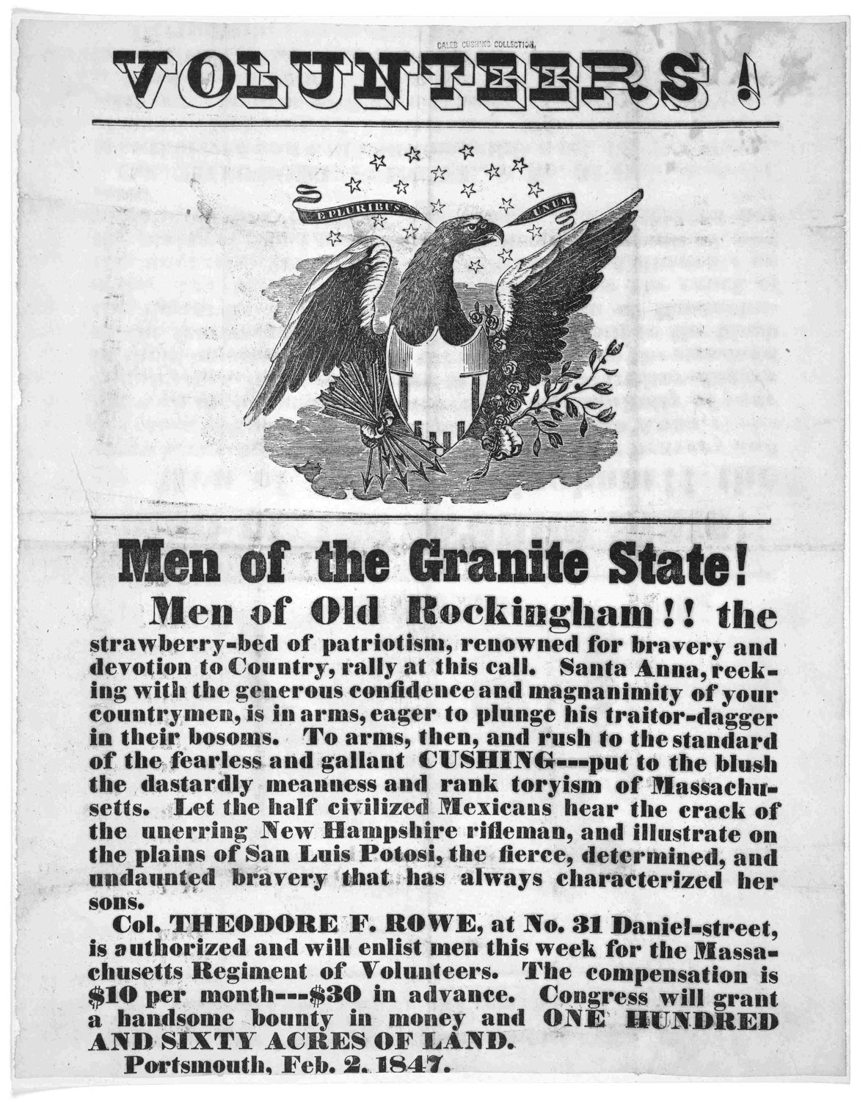

- Excerpt from Letter From Zachary Taylor to his son-in-law, Dr. R.C. Wood, October 19, 1847. (Gilder Lehrman Institute of American History, Document GLC00529.05 at http://www.gilderlehrman.org/search/display_results.php?id=GLC00529.05. Permission Granted.)

“I have not heard any of the particulars as regards...Scott's taking possession of the City of Mexico. All we have heard relative to that affair is that he was in quiet possession of that piece & that the Mexican army had dispersed; I presume there will hardly be another battle; that Santa Anna had gone no one knew where, in the direction of the Pacific .... I presume atrocity of some kind or other will grow out of our taking the city & laying it under contribution [occupation], which the Mexicans say has been done . . . The Wilmot Proviso will shake that body to its center... but I hope some compromise will be entered into between the two parties slavery & anti slavery which will have the effect of allying violent passions on both sides, which will have the effect of perpetuating...or shortening the Union.... It is to me a matter of perfect indifference whether I am even elected [as president] or not. I do not intend any party shall use me as a convenience; if drafted I intend to stand aloof, & let Whigs and Democrats [use] this matter in their own way.... Depend on it there will be great changes in the complexion of political affairs between now & the end of this next session of Congress; the Whigs as a party between ourselves I look upon as doomed.... I am gratified I took the position I did, which was not to be the exclusive candidate of any party; & if I am elected at all, it will be by a union of a portion of Whig Democrat and native votes. At any rate I am occupying a position & shall continue to do so. I hope that if not elected, I shall neither be mortified or disappointed.”

5. Excerpt from Henry David Thoreau, Civil Disobedience, 1849. (http://sunsite.berkeley.edu/Literature/Thoreau/CivilDisobedience.html. ) Note to the Teacher: Use the first paragraph of the essay.

6. Excerpt from James Russell Lowell, The Bigelow Papers, 1859. (James Russell Lowell, The Bigelow Papers. London: Trubner, 1859, pp. 4-9.

'T would n't suit them Southern fellers,
They're a dreffle graspin' set,
We must ollers blow the bellers
Wen they want their irons het;
May be it's all right ez preachin',
By my narves it kind o' grates,
Wen I see the overreachin'
O' them nigger-drivin' States.

They may talk o' Freedom's airy
Tell they're pupple in the face,--
It's a grand gret cemetary
Fer the barthrights of our race;
They jest want this Californy
So's to lug new slave-states in
To abuse ye, an' to scorn ye,
An' to plunder ye like sin.

Aint it cute to see a Yankee
Take sech everlastin' pains
All to git the Devil's thankee,
Helpin' on 'em weld their chains?
Wy, it's jest ez clear ez figgers,
Clear ez one an' one make two,
Chaps thet make black slaves o' niggers
Want to make wite slaves o' you.

Ef I'd my way I hed ruther
We should go to work an' part,--
They take one way, we take t'other,--
Guess it would n't break my heart;
Men hed ough' to put asunder
Them thet God has noways jined;
An' I should n't gretly wonder
Ef there's thousands o' my mind.

- Excerpt from Letter from Persifor Smith, 1847. (Gilder Lehrman Institute of American History, Document GLC5128 at http://www.gilderlehrman.org/search/display_results.php?id=GLC5128. Permission granted.)

“Think of our astonishing campaign, with 8800 bayonets we came down the mountain and first saw this much vaunted valley. Near 300 miles from all our resources, in the midst of a population of eight millions of people, every valley a fortress accessible only through passes which nature seems to have constructed purposely to exclude the approach of a stranger… This people have been conceived in sin & born in iniquity for ages the millions have been degraded by oppression and the few corrupted by unbridled power. Their whole moral character is debased, they have no self respect & are therefore incapable of self government; having no test within, they are guilty of any vice they think they can screen from punishment, and now all being alike base they naturally encourage each other's degradation. The best people in the country look on any reform as hopeless without the restraint & example of others and so actually seek to prolong the war with the view of benefiting by the example we give them even as conquerors. The immense crowd of office holders civil as well as military who have hitherto lived on the revenues & exactions of the government, are struggling to perpetuate the abuses by which they exist, and now then their very nationality is at stake the Congress which was to have met...is not yet a quorum. If two weeks more go by without the government being organized I do not think a peace can be made for years, and I believe indeed that they will cease to exist except as little quarrelsome, disorderly States.... Don't let any of my letter get into the paper.”

Possible evidence:

- Issues prior to war. In the lithograph of Corpus Christi, it is clear that the U.S. army is prepared for war one year before the outbreak of hostilities.

- Divisions. The divisions over the war’s purpose are clear in the article about the Wilmot Proviso. After Polk asked Congress for $2 million to purchase peace with Mexico, David Wilmot, an anti-slavery Democrat from Pennsylvania, introduced an amendment, which passed the House but not the Senate. The Wilmot Proviso illustrates the divisions between those who supported Polk, whose position was that war was “necessary and proper” to defend the boundaries of Texas, versus those who believed it was “a war of conquest.” More importantly, it illustrates the division between those who did not want slavery extended into any western territories. This division is echoed in James Russell Lowell’s poem. He distrusts the “Southern fellers” who cry for war in the hope of bringing in “Californy” and potential new slave states. He also alludes to the free state versus slave state issue related to western expansion − writing that if the slave states have their way, they will “make wite slaves o’ you.” Ultimately, he thinks that it would be best to split the states into two entities because that “has noways jined.” He believes, and thinks that “thousands” of others would support his belief, that the North and the South were never a real union. The unpopularity of the war is demonstrated in the recruitment poster for New Hampshire and its reflection of the nation's need for volunteers. In the hope of gaining volunteers, the poster attempted to cast the fight in terms familiar to most Americans of the period − fighting a “half-civilized” enemy in the name of liberty, virtue, and bravery. In return for volunteering, a “handsome bounty” is offered. Political differences between the Whigs and the Democrats are mentioned in Zachary Taylor’s correspondence. He hopes that a compromise can be made in Congress between the two parties over the issue of slavery and that any hope to keep the union together will depend on “a union of a portion of Whig Democrat and native votes.” Divisions over whether or not the war was just are demonstrated in the excerpts from Thoreau’s Civil Disobedience. Thoreau begins by arguing that “government is best which governs least” and that government derives its power from the strength of the majority. He contends that people's first obligation is to do what they believe is right, not to follow the law dictated by the majority. When a government is unjust, people should refuse to follow the law. They are obligated not to participate in evils that include membership in an unjust institution such as the government that supports slavery and is involved in an unjust, aggressive war. The war was “the work of comparatively a few individuals” who used the government “as their tool;” indeed, “the people would not have consented to this measure.”

- Consequences. Much that was predicted by Taylor’s correspondence occurs after the war. The divisions between slave and free states, South and North, continue to rage over the extension of slavery in the West. The new territory gained via the Mexican War will be a part of that ongoing conflict. Another consequence that will lead to ongoing social divisions in the nation can be seen in Persifor Smith’s letter. Racist attitudes toward the Mexicans are clear. Not only is their “whole moral character debased,” they are also “incapable of self government.” This is a foreshadowing of the ongoing social, political, and economic problems that will take place in the years ahead between Mexico and the United States.

Creative Extensions.

1. Before reading Chapter 13, ask students what they know about the era of Manifest Destiny. Write their responses in one column on the board and do not erase these for the remainder of this content unit. After reading the chapter, add a second column on the board and ask students to add new information they learned about the era of Manifest Destiny. Then, create a third column and add any unanswered questions your students may have about Manifest Destiny. For homework, ask students to investigate one or more of the unanswered questions. The next day, discuss their findings.

- After reading Chapter 13, read students an account of the war with Mexico from the perspective of Mexico. Discuss other sources that contribute to a better knowledge of the goals, conflicts, and consequences of the war from the Mexican perspective. Then, compare and contrast these views with the perspective of the war offered in the textbook. For extra credit, challenge students to write a new section for the book in which both perspectives are included.

3. Stage a classroom debate on any one of the following:

Resolved: “War exists by the act of Mexico herself,” James K. Polk. (p. 347)
Resolved: The early foundations of the American tradition of civil disobedience have their roots in the war with Mexico.
Resolved: Without the “penny press,” the fires of American nationalism would not have spread.
Resolved: Indians were more helpful than dangerous to whites as they moved westward.
Resolved: Political compromise about the issue of slavery in the territories was dead by 1850.
Resolved: If Lincoln had not won the Election of 1860, there would have been no Civil War.

4. Have students write a letter to someone living during this period

- A teenager traveling to Oregon on the Oregon Trail.
- An American citizen who in 1846 believed that the war with Mexico was immoral.
- A Chinese laborer working in California during the Gold Rush.
- Stephen Douglas as he was crafting the Compromise of 1850.
- A member of the Know Nothing Party.
- Chief Justice Taney after delivering his decision on the Dred Scott case.
- Dred Scott after he received the Supreme Court’s decision.
- President Lincoln after winning the Election of 1860.

5. Have students research the artistic efforts to romanticize the West and encourage westward expansion. They might begin with the poster by the McCormick Reaper Company (p. 344). Each student should bring to class copies of at least two artistic expressions of Manifest Destiny. Have the students tape all of these to one wall of the classroom. Then, have them browse through the art, deciding which were most realistic, least realistic, and most likely to get a person living in the mid-19th century to move westward. Bring them together for a classroom discussion. Was this art or propaganda? How and why?

- Require the class to read the full text of the Fugitive Slave Act. Then, divide the class into five different groups, each of which will conduct research about and discuss the impact of the passage of the Fugitive Slave Act in 1850. Each group will have the following six members who will research and then discuss the ramifications of the Act on their lives, and then explain whether or not they support the Act’s provisions: a wealthy white plantation owner living in the south, a middle class northern white abolitionist, an enslaved African-American male, a free northern African-American woman, a northern worker who wants to move to the West, and a poor white southern farmer.

7. Give a homework assignment in which students have at least two days to find out as much as possible about the birth of the Republican Party in the 1850s. Why did it emerge when it did? How did it contribute to the rift between North and South? To whom did it appeal and why? Then, have students research the evolution of the Republican Party over the past 150 years. On the day the assignment is due, stimulate a class discussion about the following question: Is the Republican Party of Lincoln the same Republican Party of the 20th Century?

8. Assign the following for homework. In 1855, a young relative from Philadelphia writes that he or she is tired of the crowded city and wants to join you out West. From the perspective of a miner, a farmer, or a rancher, write a letter back to your relative with a fair appraisal of the opportunities, challenges, and conditions of life in your specific region. Describe your precise location, your living quarters, surrounding countryside, climate, and social conditions. What should your relative bring? Comment on his or her prospects for marriage and family life. When you are finished, explain how your advice would change if your correspondent were Mexican, Indian, Chinese, African-American, European, male, or female. (Pick two of these scenarios.)

9. Stimulate a class discussion on the Election of 1860. Ask students to explain Brinkley’s statement that “The presidential election of 1860 had the most momentous consequences of any in American history. It was also among the most complex.” (p. 363) Refer them to the map of the Election provided in the text (p. 363) or the interactive map available in the Online Learning Center for Chapter 13. Ask them to share their observations of the election based upon the maps. Then, project two maps − one of the “Pre-Civil War Free vs. Slave States” and the other from the “2004 Presidential Election Results” available online at http://pudding.oneillwebservices.com/map_nowvsthen.jpg. Ask them to compare and contrast the results of the two elections and the ways in which various regions voted in both elections.

- Invite students to watch any of the following movies at home, either with their families or with a group of friends from class: Fort Apache, High Noon, The Ox-Bow Incident, The Adventures of Huckleberry Finn, Moby Dick, or The Alamo. Then, have them address the following questions about the movie:

- What does this production tell you about the period of American history examined in this chapter?
- Do you think this film was a realistic portrayal of an historical event? Why or why not? Be specific.
- In your opinion, is this movie of any real use to understanding this period in American history? Be specific about how and why − or why not.

